**Creating GUI application using python-Tkinter**

**AIM**:

To create a GUI application using python-Tkinter.

**OBJECTIVE**:

Creating a GUI application using Python and Tkinter serves the purpose of building an interactive and visually accessible interface. This application aims to enhance user interaction, present information in a visually appealing manner, and potentially automate tasks. Through the graphical interface, users can input data, customize settings, and receive feedback, contributing to a user-friendly and efficient experience. The objectives may vary based on the specific needs of the application, ranging from data presentation to task automation or seamless integration with other functionalities. Clearly defining these objectives before development ensures a focused and purposeful design.

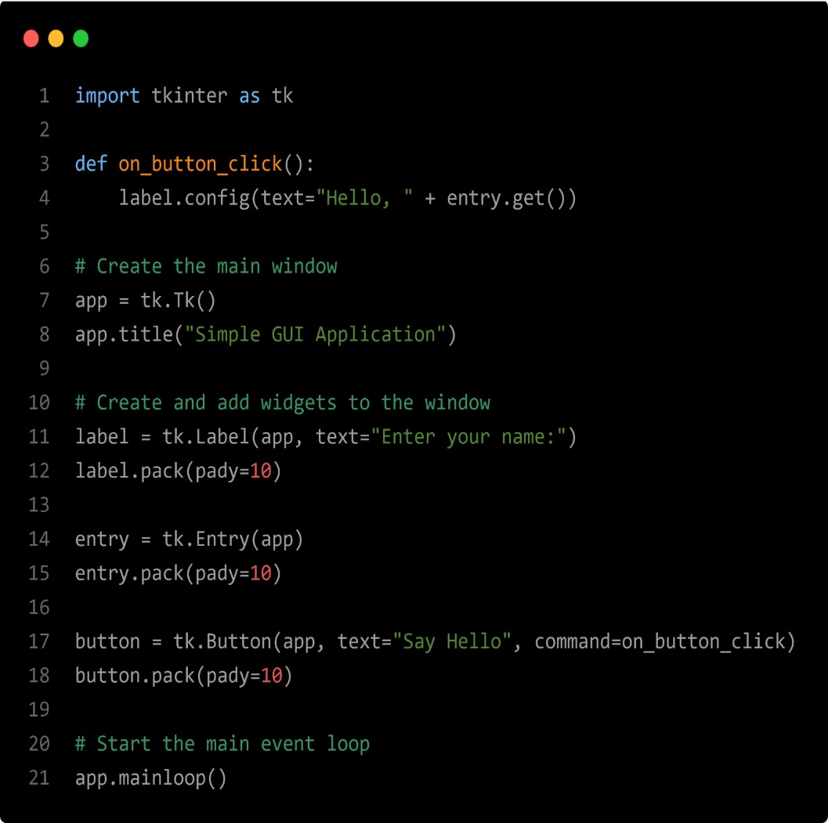**PROGRAM**:

**OUTPUT:**

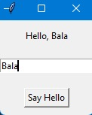

**CONCLUSION:**

In conclusion, developing a GUI application using Python with Tkinter provides a straightforward and efficient way to build user interfaces. Tkinter’s simplicity makes it accessible for beginners, while its versatility allows for the creation of complex applications. With its native integration into Python, Tkinter ensures cross-platform compatibility. Although it may lack some advanced features found in other GUI frameworks, Tkinter remains a solid choice for quick prototyping and developing desktop applications with a clean and functional user interface.